Basics of Redirection (error handling)

1) Write a program in any language like C, C++, Java.

2) And redirect the output or error to a new file.

OR

3) Create a text file with some content like your name, address.

4) Redirect the content to a new file.

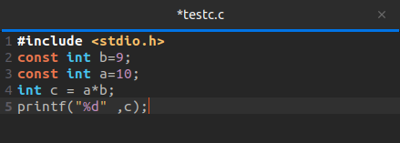

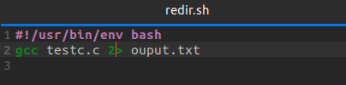

TERMINAL

